# **CPSC 1045: Assignment 9 [20 marks]**

**Resources**

* [http://www.w3schools.com/js/js_objects.asp](http://www.w3schools.com/js/js_arrays.asp)

**Overview**

In the previous assignment you created a web page which calculated the price for a single take out meal. For this lab you will create an entire ordering system that will allow a person to order multiple meals, and then tell the user the total price for their order. You should use your previous assignment as a starting point.

If you have not finished the last assignment, a sample solution will be provided for it on D2L. You may start working on this lab using this solution as your starting point.

**You will have to modify and rewrite some parts of assignment 8** and add new functionality to make a complete ordering system. Rewriting the same code is a process called **refactoring** and it is an important part of keeping software maintainable and up to date as the application/website evolves.

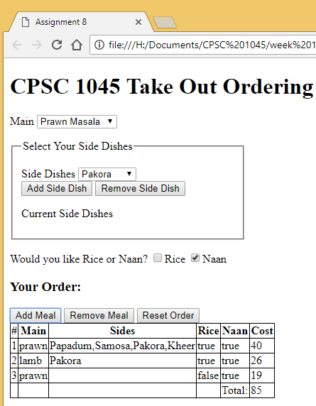

**Lab work**

1. Create a **constructor** to make an object that represents a single take out **meal** with the following properties

|  |  |
| --- | --- |
| **Property** | **Description** |
| main | Property for representing the main dish |
| sides | Property for storing all of the side dishes |
| rice | Property for representing rice selection |
| naan | Property for representing naan selection |

**Note**: Your constructor should store a copy of the side dish array from the current global array using the **slice() function** rather than simply using the assignment operator.

1. Refactor your code for calculating the cost of a single meal. The refactored function should:
   * Be a function called calculateCost(mealObject)
   * Accept a meal **object** as a parameter
   * Return the total calculated cost of the meal that was passed as a parameter
2. Your program will now need to keep track of multiple meal objects using an array of objects. Your program will need to be able to add a meal object to an array representing the customer’s order. Finally, your program must display all of the meals ordered and the total cost of all the meals in the array. To handle adding and removing meals from the order you will need three more buttons: add meal, remove last meal, and reset order.
   * Add Meal  
     This button should create a meal object and add it to the customer order array. Use your constructor to create an object from the current meal information selected and add this object to the order array. Update the displayed information.
   * Remove Last Meal  
     This button removes the last meal from the customer order array. Pop the last item off the order array and then update the displayed information.
   * Reset Order  
     This button should remove all meals from the customer order array, by resetting the order array to an empty array and then updating the display.
3. Make sure to create a function to **neatly** display the customer order information to the page as a table. Then this function can simply be called by all three of the functions created in the previous step.
4. Submissions
   * Submit to D2L ONE zip/archive file containing all of your files from this lab
   * If you do not zip your files, you will receive **ZERO** for this lab (<http://www.wikihow.com/Zip-Files-Together>)
5. Grading  
   Marks will be assigned as follows:
   * + 4 marks for correctly implementing step 1
     + 3 marks for correctly implementing step 2
     + 3 marks for adding new buttons with onclicks
     + 3 marks for Add meal
     + 2 marks for Remove Last meal
     + 2 marks for Reset
     + 3 marks for correctly/neatly implementing step 4